Organic Matter Depletion

* Soil data derived threshold is variable (range of susceptibility)
* Soil rating adjusted upward, if irrigated
* Existing condition based on planner observation of managements, plant litter, RHA and PCS elements

For each resource concern listed, an overview of the CART streamlined assessment method is described. Key concepts for each of these are:

* “thresholds” (treatment/attainment goals used in lieu of planning criteria by CART)
* Thresholds are either fixed @ 50 points, or are vary between 40 and 60 points depending on the site’s soil characteristics
* Existing conditions (a.k.a. benchmark condition) are indicated by planner answered questions
* Practice points (for existing and planned practices) are applied in the assessment to indicate the levels of conservation relative to the applicable threshold for the land.

**Step 1 Threshold**

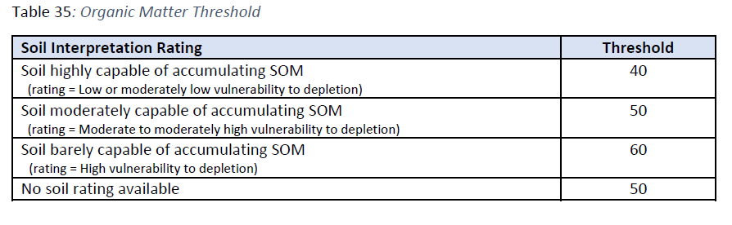

**Step 2 Example: sliding thresholds based on soil interp. and existing points matrix crossing soil interp. and management questions**

Existing condition points are based on the combination of the soil’s inherent capability to maintain or accumulate SOM with the cropping management system benefits for cover/residue/biomass of all crops and cover crops in the rotation combined with the effects of harvesting, grazing and tillage. Individual points for associated practices like crop rotation, cover crop and residue management are added to this system level credit.

|  |  |  |  |  |  |
| --- | --- | --- | --- | --- | --- |
| **Soil Interpretation** | **Variable** | **Rapidly Depleting SOM** | **Depleting SOM** | **Maintaining SOM** | **Not assessed** |
| **Thresholds** |
| **Soil highly capable of accumulating OM** | 40 | 0 | 10 | 40 | -1 |
| **(Low vulnerability to depletion)** |
| **Soil moderately capable of accumulating OM** | 50 | 0 | 10 | 50 | -1 |
| **(Moderate vulnerability to depletion)** |
| **Soil barely capable of accumulating OM** | 60 | 0 | 10 | 60 | -1 |
| **(High vulnerability to depletion)** |
| **Not rated** | 50 | 0 | 10 | 50 | -1 |

* Maintaining SOM represented the idea of ‘sustainability’, therefor should be set as the CART threshold.
* Conservation Practices can be used to meet the threshold, except on non-irrigated land with soil having a high vulnerability to SOM depletion.
* CSP enhancements can be used to take land past the threshold into the “building SOM” category.